**APS1052 – Final Project**

Sector Rotational Momentum with Predictive Models



Bryan Tarras (998853600)

Natalie Mustard (1003748778)

**Introduction:**

Momentum investing strategies have been executed successfully for many years by experienced traders. Foltice & Langer (2015) wrote a paper on implementing a practical strategy for individual investors with limited access to capital, smaller portfolio of stocks with a long-only constraint. In contrast, results by Nadler & Schmidt (2019) demonstrate that the conventional momentum pattern may not be universal. Nonetheless, there have been numerous successful instances where momentum investing has generated returns. These warrant further investigation of this investment strategy. Another interesting momentum strategy utilizes a rotation-based strategy for a single asset class, such as stock ETFs within different sectors of the market (industrial, healthcare, technology, financial, energy, etc.). A white paper by Faber and O'Shaunessey (2010) sought to evaluate the effectiveness of a rotational momentum strategy. Using sector/industry group data going back to the 1920s, Faber found that a simple momentum strategy outperformed the buy-and-hold strategy approximately 70% of the time.

In previous studies conducted by group members it was shown that modifications to the rotational momentum program provided in APS1051: Portfolio Management (i.e. optimization of lookback periods, frequency of trades (holding period), and ETF selection) can result in great performance. For this final project we will seek to expand on the work conducted in APS1051: Portfolio Management. To be specific we will look to add a predictive component to the evaluation of which ETF is selected for investment at the end of each holding period. The motive for doing so is rooted in the fact that it was observed that with long holding periods, momentum performs well at the beginning of the period but sharp drops in ETF prices can occur as we reach the later points in the holding period. This can be remediated by incorporating risk management into the portfolio or by incorporating predictive analytics to gain better confidence in returns at the ends of the horizon.

From the final project in APS1051: Portfolio Management it was found that after brute force optimization of A_periods, B_periods, and frequency of trades (holding period), the best performing combinations on the Test set always involved a frequency of 20 Weeks. As such for the purposes of this project, this holding period will be held as a fixed variable. That is to say the holding period will remain at 20 weeks. For the predictive component we will look at using various regression and classification models to predict the 20 Week return of each ETF being evaluated (more on the specific models and the features used can be found in the Machine Learning models section of the report). By having the target variable as the lagged 20 Week return (100 trading days), we can use our features to predict returns at the end of this holding period.

The intent of adding in a predictive component is to reduce volatility and create a safer and more robust investment algorithm. Eighteen industrial sector ETF that represent a broad range of stocks in the US market were chosen as the group of securities to execute the rotational momentum strategy, along with 1 bond index (SHY). ETF daily closing prices from 2010 – 2017 were selected as the training set, and data from 2017 to 2019 was selected as the testing set. Splitting the data into training and test sets reduced the risk of overfitting of the dataset and yields confidence in the programs ability to execute profitable trades on unseen data.

For ETF selection the program incorporates the use of k-means clustering. This facilitates the automatic categorization of ETFs with similar volatility, rather than manually selecting ETFs. ETFs with similar volatility reduced the overall bias in the portfolio and provided assurance that specific low-volatility ETFs were not dominating the portfolio consistently.

**General Rotational Momentum Concept Review:**

The basic principle behind rotational momentum is to keep investors out of the market during extended downtrends and in the market during extended uptrends. In our application of Rotational Momentum, we are focusing on Sector Momentum. To this extent we are looking exclusively at ETFs which track sectors of the US market. The reason for using ETFs specifically is because they provide instant diversification. By using ETFs, diversification can be provided easily among classes, markets, as well as sectors.

In this implementation, sector ETFs are invested in for a specified optimized holding period to take advantage of the momentum phenomenon. An optimized lookback period must also be determined. In this application lookback period refers to the lookback associated with two different momentum periods “A_periods”, “B_periods”, and a volatility period of “S_periods”. After each prescribed holding period, the portfolio is rebalanced based on the sector ETF with the best performance in terms of momentum and volatility. In essence the investment is “rotated” between the sector ETF displaying the strongest performance. This rotation strategy can be applied to sub classes of assets, such as ETFs, or multi class assets as well. For the purposes of this assignment we shall focus on the ETF class of securities.

A graphical representation of the trading strategy can be seen in Figure 1 below.

Figure 1 - General Rotational Momentum Strategy

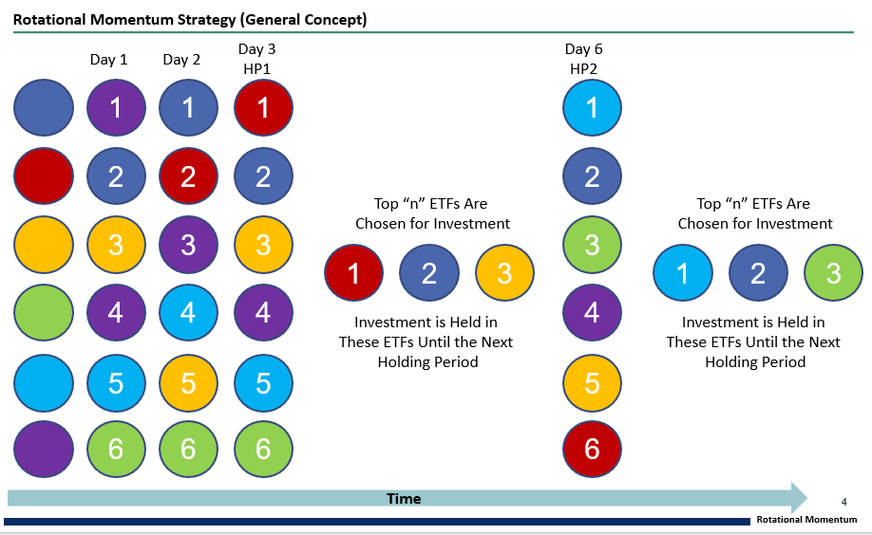

In the figure above, the 6 ETFs are evaluated each day. Once a holding period has been reached (in this case day 3), the “n” number of ETFs displaying the strongest performance based on Momentum and Volatility are selected for investment. They are held until the next holding period in which the new best “n” ETFs are selected for investment. This continues as time goes on.

**Rotational Momentum with Predictive Models Concept Review:**

The work presented here takes the General Concept of Sector Based Rotational Momentum and extends it a leg further to include predictive models to forecast out future returns of assets such that these are included in the evaluation and selection of which ETF is chosen for investment each holding period.

The algorithm that we present in this study makes use of the following parameters for evaluation of the ETFs at each holding period:

|  |  |
| --- | --- |
| **Parameters of Interest in Modified Rotational Momentum Program** | |
| *Parameter* | *Description* |
| Aperiod | Originally a short-term moving average (rolling average or running average) |
| Bperiod | Originally a long-term moving average (rolling average or running average) |
| Speriod | A period for which volatility is calculated for each ETF |
| Frequency | Holding Period, Ie. How long an ETF is held for before selection of new ETF or set consisting of “n” ETFs.  In this application the holding period is held constant at 20W. |
| 20W – Predicted Return | Returns for each ETF is lagged by 20 Weeks and a separate prediction algorithm is trained for each ETF to predict the 20W return.  In total 19 prediction models were created for each model type examined. |

Revisiting the original concept diagram, the modifications presented here can be seen visually in Figure 2 below.

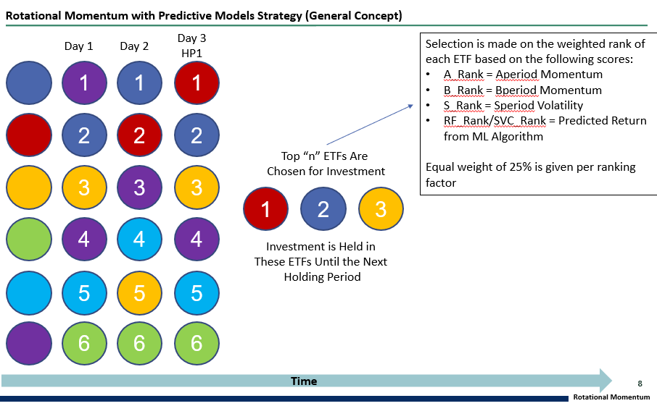

Figure 2 - Rotational Momentum with Predictive Models Strategy

In the figure above, similar to the original concept, everyday each ETF is ranked based on its score associated with Momentum and Volatility. The difference here is that in addition to these 3 ranking elements for the ETFs (Aperiods, Bperiods, and Speriods) the rank associated with each ETFs predicted 20W return is also incorporated. That is to say the All_Ranks dataframe consists of the ranks associated with Aperiod, Bperiod, Speriod, and RF/SVC_rank. Each of these ranking components is present at a 25% evaluation. That is to say equal weighting is given to each factor.

**Review of Past Work – Vanilla Sector Rotational Momentum:**

In previous studies involving no predictive components (Ie. Vanilla Sector Rotational Momentum) Aperiods, Bperiods, and Frequency were optimized through brute force parameter optimization to determine combinations which maximized Total Annual Return and Sharpe Ratio. The parameters optimized can be seen in Figure 3 below.

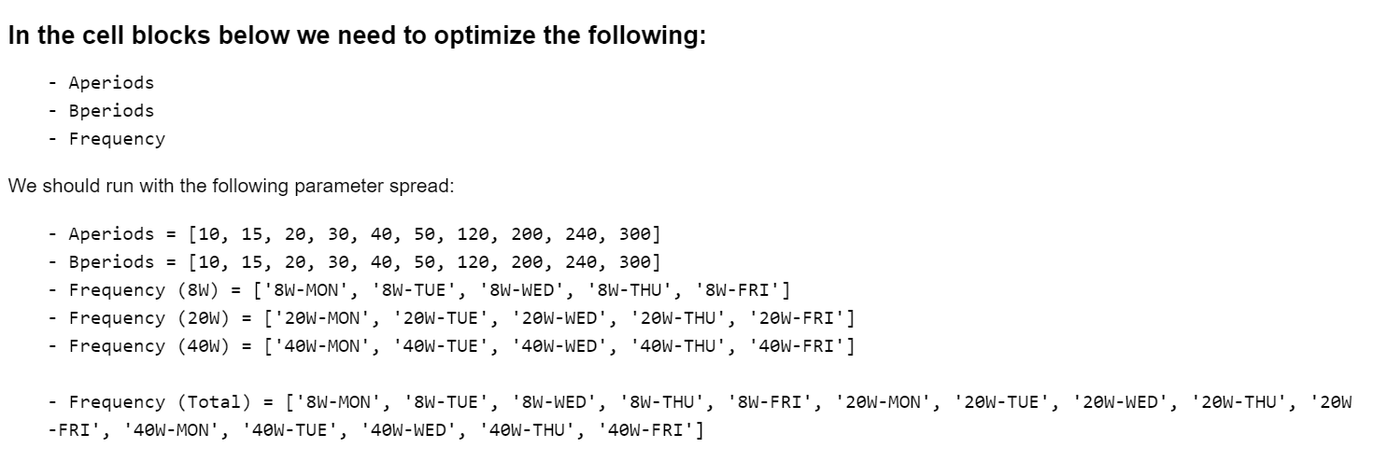

Figure 3 - Vanilla Sector Rotational Momentum Parameter Combinations

As can be seen in the figure above 1,815 parameter combinations were tested on a training dataset consisting of the years 2014-2016. Of these parameter combinations, the top 50 were selected to run on the test set spanning from 2017-2019. Upon completion it was found that all top performing parameters for both Training and Test sets involved a frequency of 20W. Under this observation, it was concluded that future programs should fix the holding period at 20W-THU (the best performing holding period).

In addition, Figure 4 below shows the equity curves for the best performing parameter combinations for both the training and testing sets.

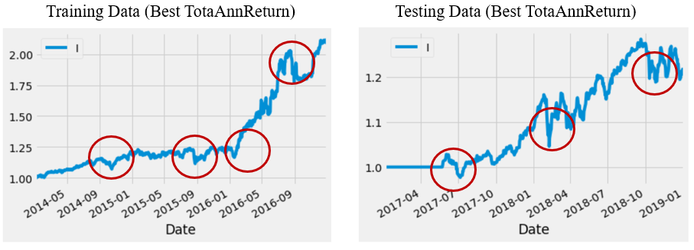

Figure 4 - Training and Test Set Best Performing Parameters (Vanilla Sector Rotational Momentum)

From the figure above it can be seen that the algorithm which is solely dependent on Momentum and Volatility performs well at the beginning of the frequency period but ends up performing poorly at the extremes of the holding period. Being in a position for extended periods of time, as is present in the trading frequency of 20 Weeks, can have significant detrimental effects on returns.

Some options to help rectify this include incorporating Risk Management through the use of 200 MA pullouts, or through tiered laddered investment strategies, or to incorporate predictive returns for ETFs across the holding period. Doing the latter would give confidence to the performance of which in ETF selection at the extremes of the holding period.

This report covers the incorporation of Predictive Returns across the 20W period for each ETF. As will be covered in the Machine Learning Models section of the report, various models for 20W predictions have been constructed and trading algorithms involving Random Forest Regression, Random Forest Classification, and SVM Regression completed.

**ETF Selection:**

Eighteen industrial sector ETFs that represent a broad range of stocks in the US Market along with the SHY ETF were chosen as the group of securities to execute the modified Sector Rotational Momentum with Predictive Models. These 18 industrial sector ETFs were pared down from a list of 65 ETFs based on K-Means clustering for volatility. That is to say, ETFs similar in volatility to one another were selected. The Sector Based Rotational Momentum program penalizes volatility thus, to avoid domination by low volatility securities ETFs with similar volatility were selected. A list of the US industrial sectors that the ETFs represent can be seen in Figure 5 below.

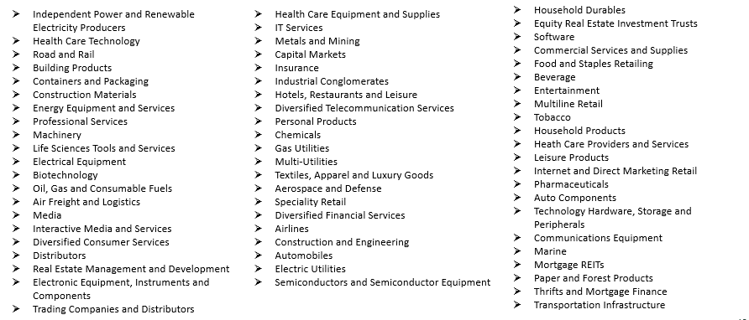

Figure 5 - US Industrial Sectors

The results of the K-means clustering for the 18 selected ETFs an be seen in Figure 6 below. 3 and 5 clusters were generated for comparison purposes.

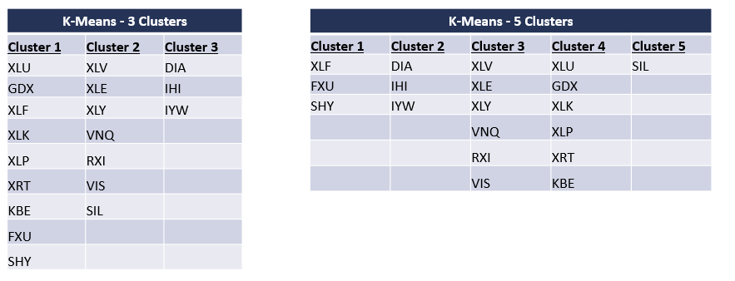

Figure 6 - K-Means Clustering Results

**Sector Rotational Momentum with Predictive Models Algorithm Overview:**

In summary of the modifications to the Rotational Momentum Strategy are as follows:

* Training-Testing Data
  + ETF daily closing prices from 2010-2017 were selected as the training set, and data from 2017-2019 were selected as the testing set
* Clustering algorithm to categorize ETFs
  + ETFs with similar volatility reduced the overall bias I the portfolio and provided assurance that specific low-volatility ETFs were not dominating the portfolio consistently
* Optimization of Aperiods, Bperiods, and Speriods
  + The Sector-Based Rotational Momentum program was optimized on 288 combinations of Aperiods, Bperiods, and Speriods (Ie. 288 trading models were optimized)
  + The Frequency was held at 20W-THU
* Addition of Predictive Modelling for 20W Returns
  + 20W Returns were lagged in a training set consisting of 2010-2017 returns
  + 19 separate models using Random Forest Regression, Random Forest Classification, and Support Vector Machine Regression were trained and optimized to predict returns on a test set from 2017-2019
  + Predictions for returns were ranked for each ETF and added as a separate evaluation component in the determination of which ETF to select at the end of the holding period

**Machine Learning Models: Data retrieval, Feature Engineering, and Data Preparation**

Data was collected from WRDS from 2009 to 2019, avoiding the 2008 financial crash which would undoubtedly skew results. The price, share volume, closing bid, closing ask, holding period return, market return, and SHROUT data was selected for each ETF.

In order to engineer features for our machine learning models, several statistical measures were calculated for each ETF:

* Price, bid ask spread, market value, dollar volume, 1 month returns, 3 month returns, 12 month returns, rolling 3 month (63 day) volatility of the daily ETF returns.
* Rolling 12 month standard deviation, rolling 12 month standard deviation of the daily market returns, rolling 12 month covariance of the daily ETF returns and daily market returns, rolling 12 month Beta, rolling 12 month Idiosyncratic volatility of the daily returns, rolling 12 month squared Beta.
* Rolling 3 month standard deviation of the daily returns, rolling 3 month standard deviation of the daily market returns, rolling 3 month covariance of the daily returns and daily market returns, rolling 3 month Beta, rolling 3 month Idiosyncratic volatility of the daily returns, rolling 3 month squared Beta.

Next, the data was prepared for each ETF to be input into each machine learning model. The 20 week return was calculated as the target variable to be predicted. The data was split into testing and training sets by year, with the training set consisting of 2009 to 2016 data and the testing set consisting of 2017 to 2019 data.

For the classification models, the returns needed to be converted into target labels: either a 0, 1, or 2 label. Using the 20 week return values, an upper and lower bound were defined by calculating the 33rd and 66th percentiles respectively, ignoring NaNs. The target return was then converted to 0 if the return was below the lower bound, 1 if the return was between the upper and lower bounds, and 2 if the return was higher than the upper bound.

**Machine Learning Models: Outline**

Random forest, support vector machine, and gradient boosting algorithms were defined for both regression and classification models. For the random forest model, a ML pipeline was defined consisting of the standard scaler function, SelectFromModel function which would automatically select features based on a given feature importance threshold, and the final stage of the pipeline was the machine learning model itself. For the support vector machine and gradient boosting algorithms a MinMaxScaler was used instead, and feature importance was not considered.

A parameter grid was built for each algorithm, by selecting the desired hyperparameters to tune:

* Random Forest: n_estimators, max_features, max_depth, threshold
* Support Vector Machine: kernel, C, gamma, degree
* gradient boosting: loss function, n_estimators, max_depth, alpha

K-fold cross validation was performed on the parameter grid with k=5 in order to reduce overfitting of the model on the training set.

Once the optimal hyperparameters were found, the best model was selected, fit to the training set, and used to make predictions on the testing set.

**Machine Learning Models: Results**

Overall, the models did not give very good results for predicting exact return values, however for our purposes the correlations (general upward/downward movement of the returns) were sufficient for the trading algorithm.

For each model, the training R2, testing R2, and mean squared error were calculated from predicted versus actual return values. Additionally, for classification models the accuracy score was calculated for both testing and training. The random forest results are shown below in Table 1.

Table 1: Random Forest results for each ETF

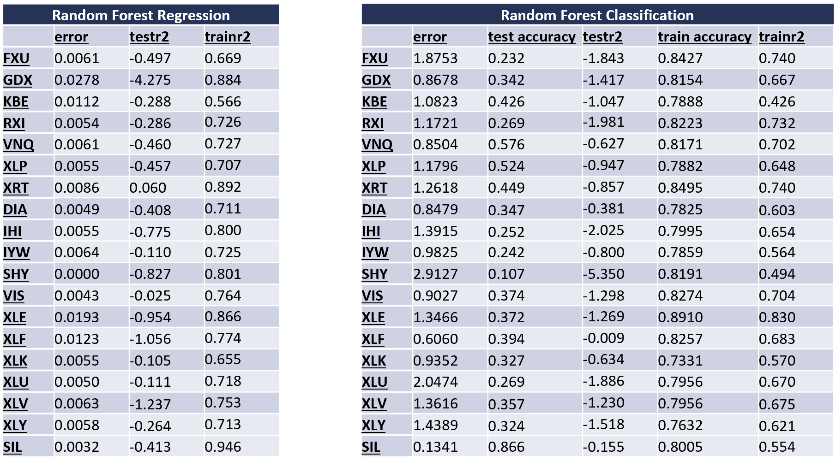

As shown below in Figure 7, the random forest regression model predictions did a very good job and following the general up and down trends of the actual values:

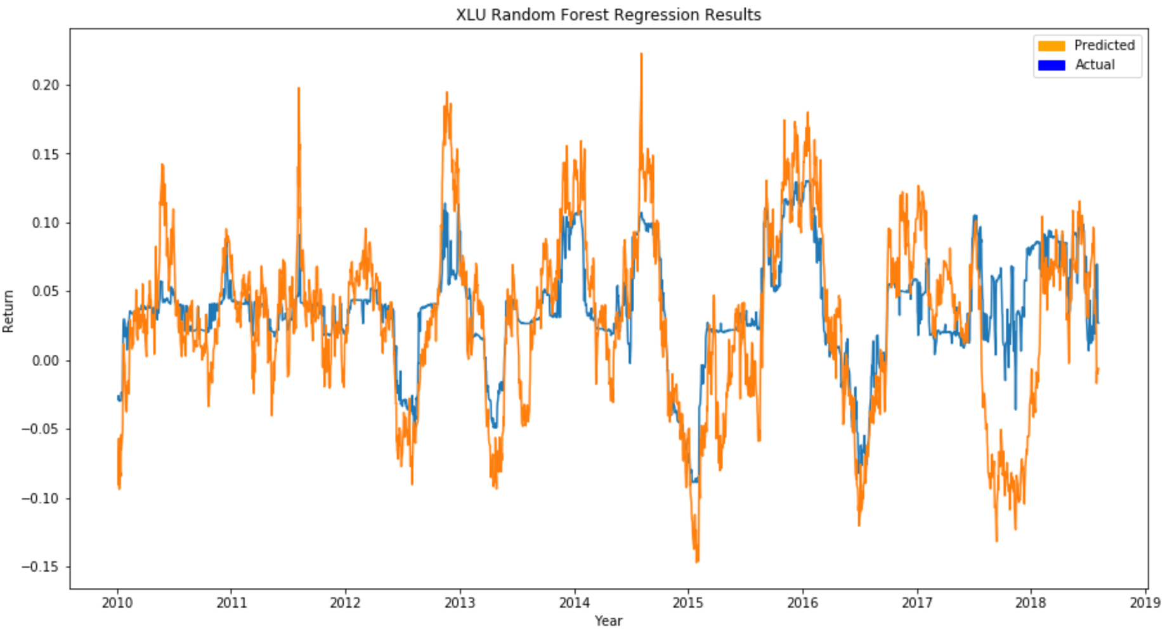

Figure 7: Graph of actual and predicted return values for XLU using Random Forest Regression

The random forest classification did not perform as well as the regression as shown below in Figure 8.

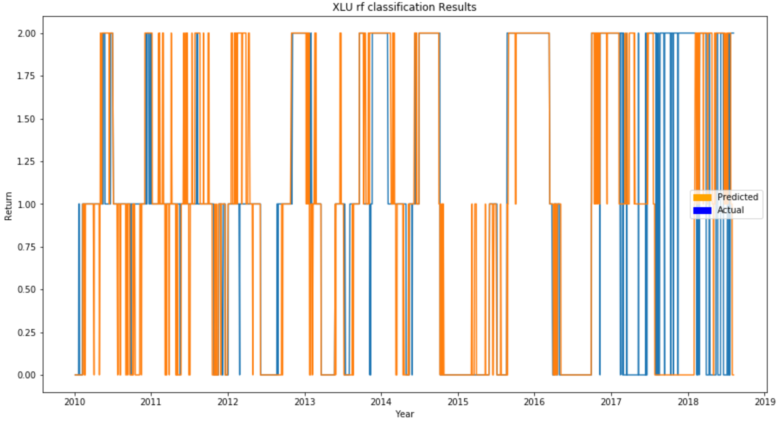

Figure 8: Graph of actual and predicted return values for XLU using Random Forest Classification

The results of the support vector machine regression and classification models for each ETF is shown below in Table 2.

Table 2: Support Vector Machine results for each ETF

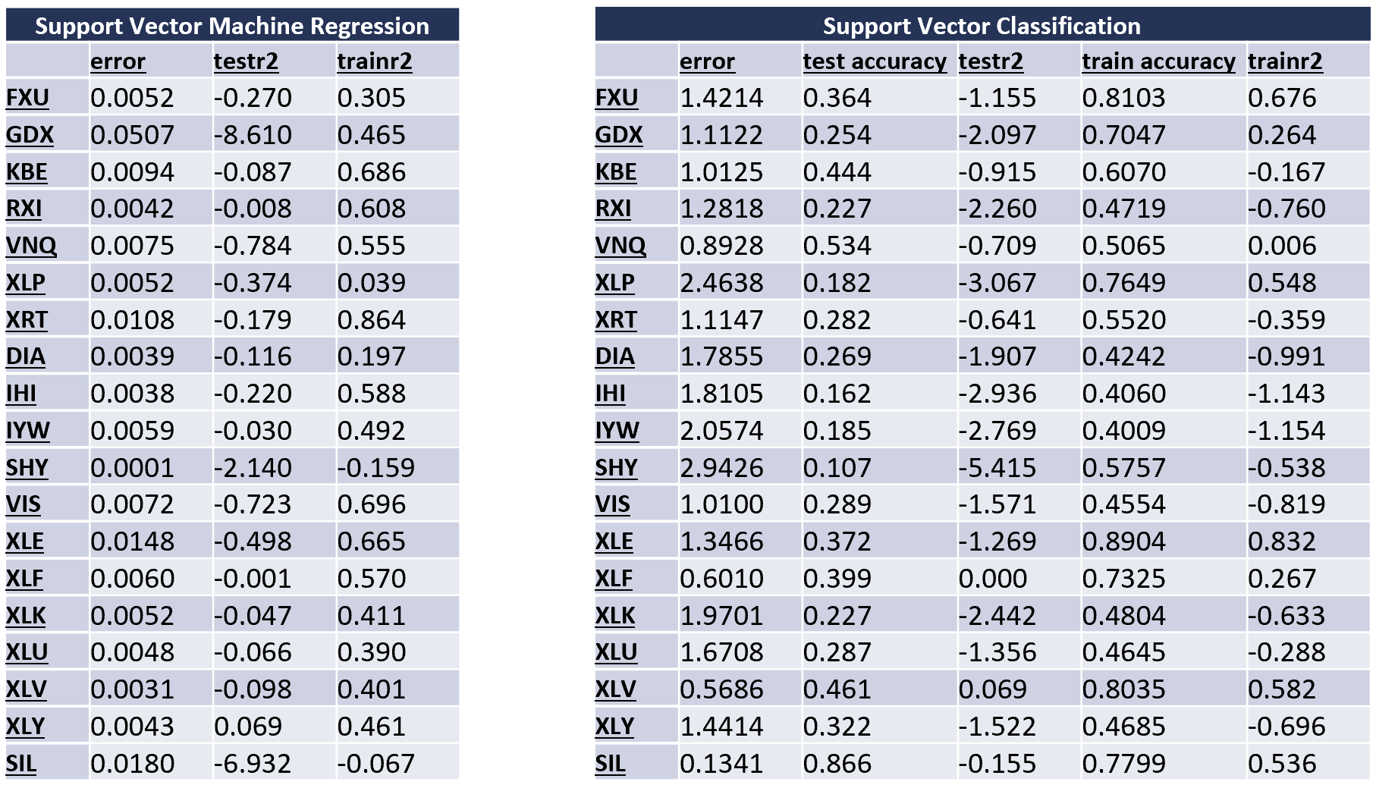

Similarly to the random forest regression, the SVM regression predicted values were sufficiently correlated to the actual return values as shown below in Figure 9.

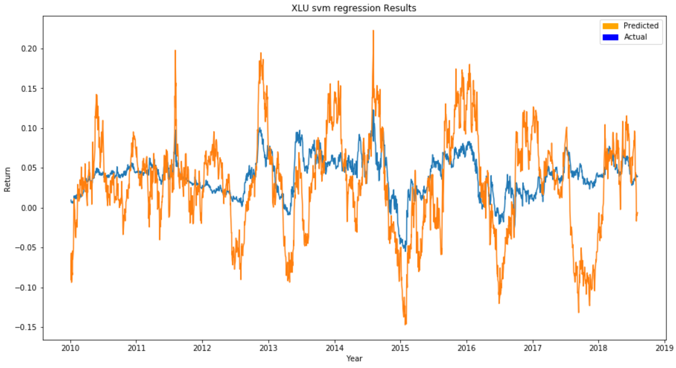

Figure 9: Graph of actual and predicted return values for XLU using Support Vector Machine Regression

The SVM classification did not perform as well as the regression models, but does appear to predict on the testing data better than the random forest classification model as shown below in Figure 10.

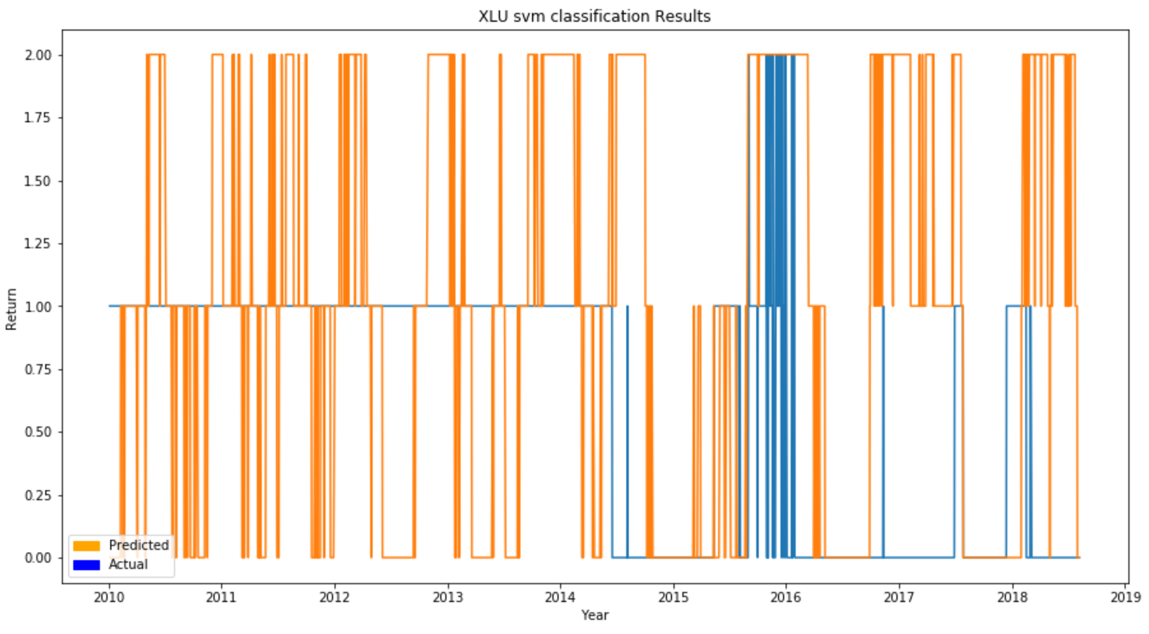

Figure 10: Graph of actual and predicted return values for XLU using Support Vector Machine Classification

The results of the support vector machine regression and classification models for each ETF is shown below in Table 3.

Table 3: Gradient Boosting results for each ETF

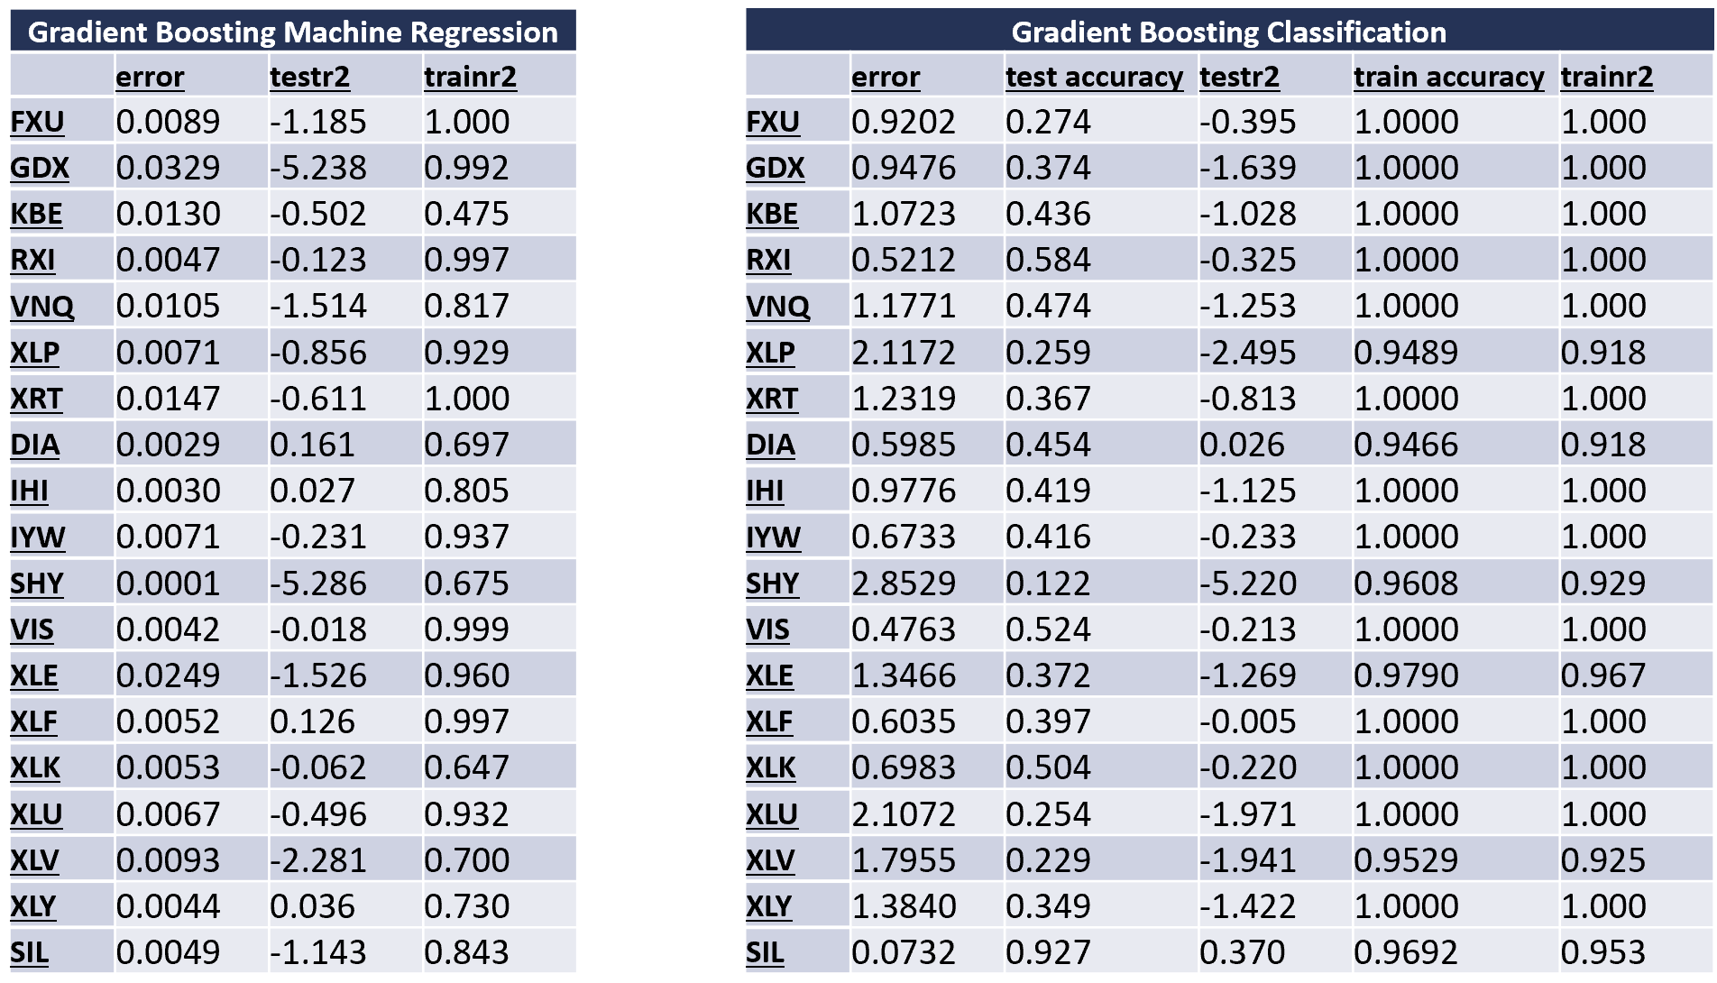

Using gradient boosting, the models were overfitting on the training set, with some classification predictions having a training accuracy of 100%. This was expected, as gradient boosting is a decision tree ensemble method that is prone to overfitting. These results can be seen for the regression and classification predictions below in Figure 11 and Figure 12 respectively.

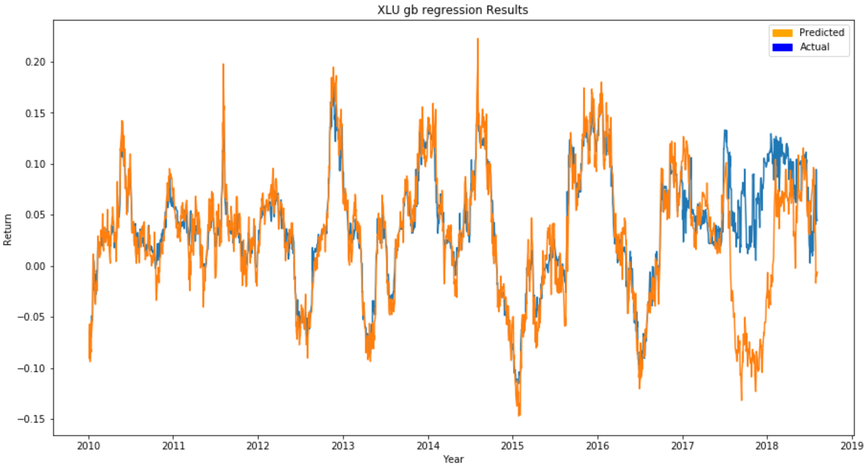

Figure 11: Graph of actual and predicted return values for XLU using Gradient Boosting Regression

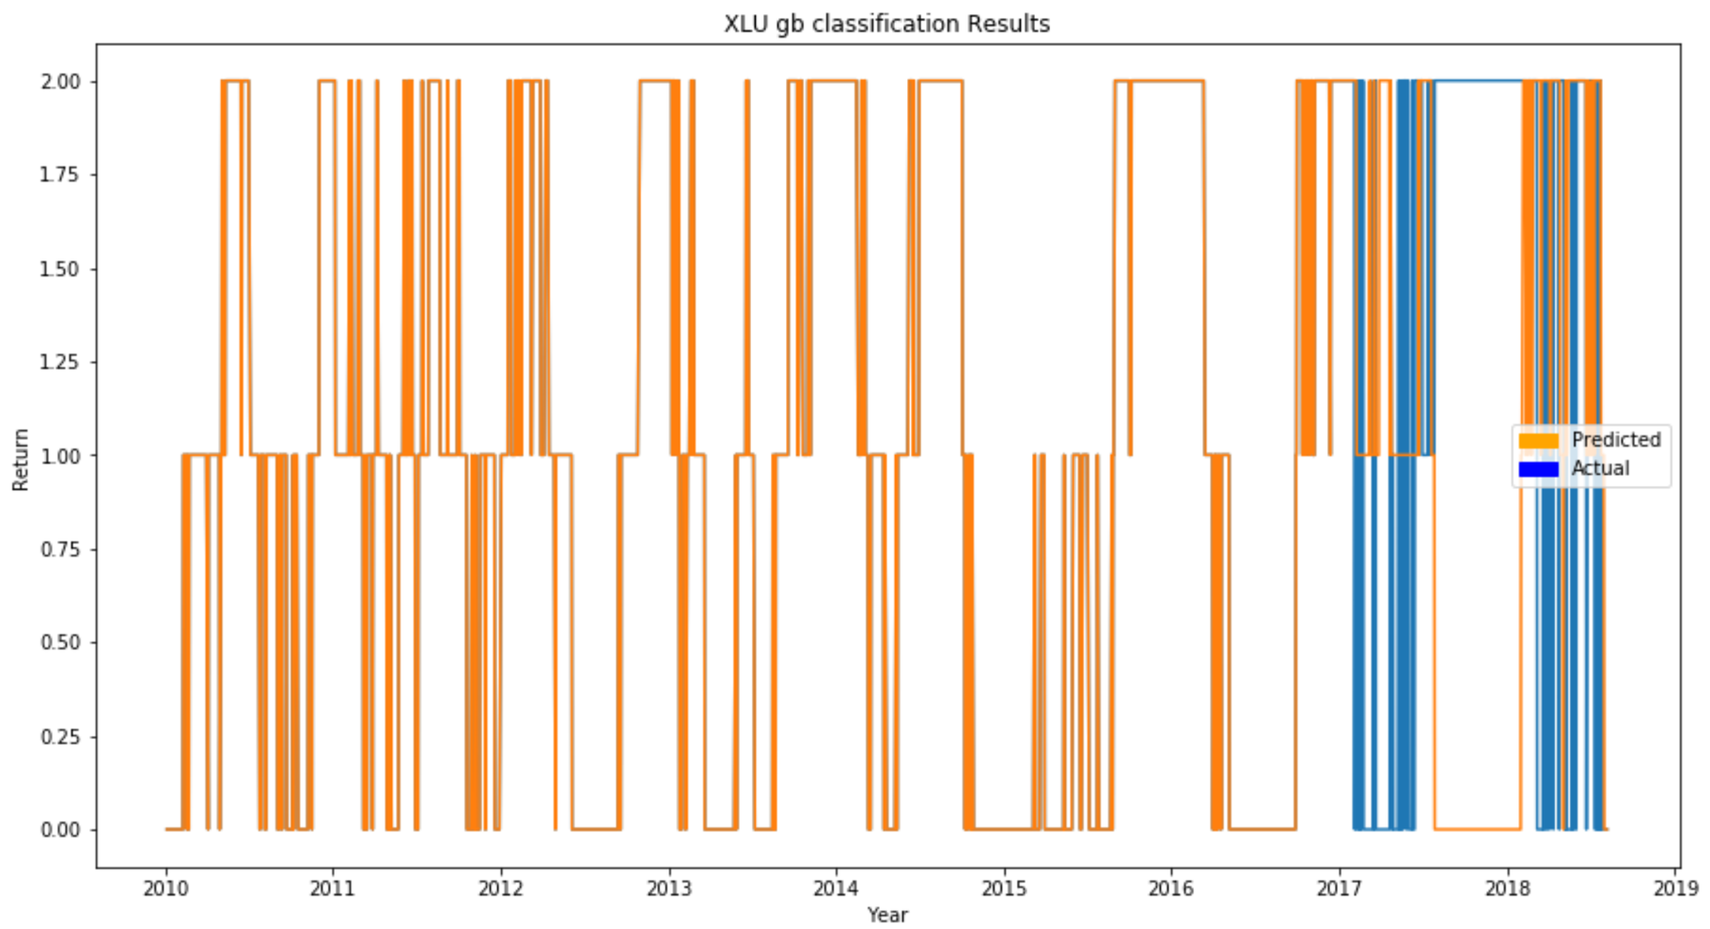

Figure 12: Graph of actual and predicted return values for XLU using Gradient Boosting Classification

**Machine Learning Models: Summary of Results**

For each machine learning model, the average was taken across all ETF’s for the mean squared error, testing R2, training R2, testing accuracy, and training accuracy. The results are summarized below in Table 4.

Table 4: Mean score values across all ETF's for each ML model

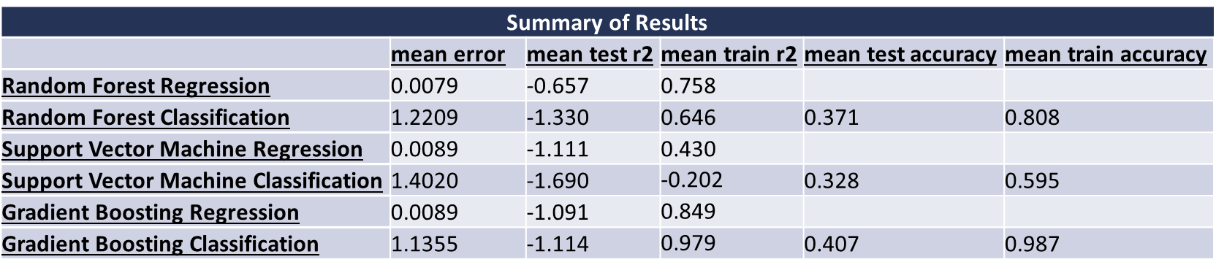

* Random forest regression had the lowest mean error and the highest mean test r2
* Random forest classification had one of the highest mean error
  + SVM classification also had one of the highest mean error
* Models were overfitting on the training data for every algorithm
  + Gradient boosting was overfit the most
  + Had 100% accuracy for some training predictions
* All models had negative mean test r2 scores
  + The models performed worse than just using the average on the test data
  + SVM classification was the worst performing algorithm overall

**Baseline Model – Sector Rotational Momentum with No Prediction Components:**

For benchmark purposes a trading algorithm involving ETF selection based only on Aperiods, Bperiods, and Speriods evaluation was constructed. This will be referred to as the Baseline Model moving forward.

The program runs the complete 288 parameter combinations of Aperiods, Bperiods, and Speriods, followed by ranking of the top performing parameter combinations in terms of Total Annual Return and Sharpe Ratio. From here the top 50 performing parameter combinations with respect to Total Annual Return are run on the test set. The parameter combination that performs best on both sets is selected as the final parameter combination for the trading system.

The results for the best performing training parameters can be seen in Figure 13 below.

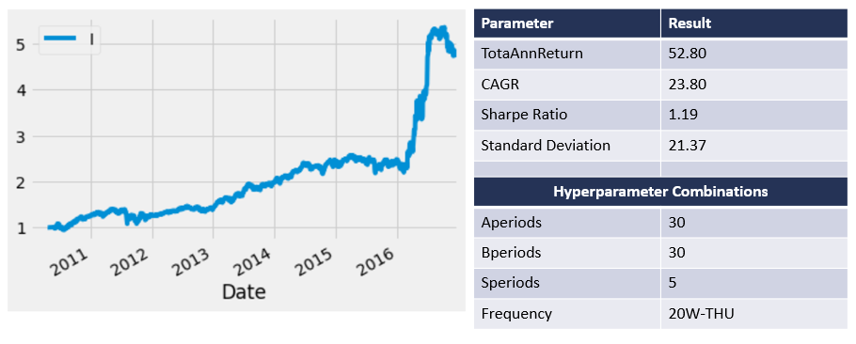

Figure 13 - Baseline Model Top Performing Training Parameters

As can be seen the performance of the baseline model without prediction components performs very well on the training set with a Total Annual Return of 52.80% and a Sharpe Ratio of 1.19. The parameter combination that makes this possible is Aperiods = 30, Bperiods = 30, and Speriods = 5.

After running the top 50 performing parameters on the test set, the best performing combination was found to the the following:

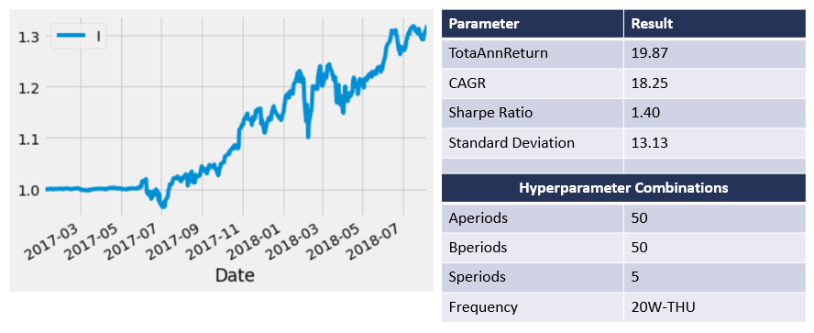

Figure 14 - Baseline Model Top Performing Testing Parameters

As can be seen in Figure 14 above the best performing parameter combination on the Test Set and Training Set yielded a Testing Set Total Annual Return of 19.87% with a Sharpe Ratio of 1.40. The parameter combination that made this possible was Aperiods = 50, Bperiods = 50, and Speriods = 5.

These results will be what the Algorithms involving a predictive component are compared against to determine efficacy for the inclusion of predictive components for returns in the trading Sector Based Rotational Momentum strategy.

**Sector Rotational Momentum with Random Forest Regression Predictions:**

The first trading system to compare against the Baseline Model is a Sector Based Rotational Momentum Program that incorporates 20W predicted returns for each ETF using Random Forest Regressions.

The top training parameter combinations in terms of Total Annual Return can be seen in Figure 15 below.

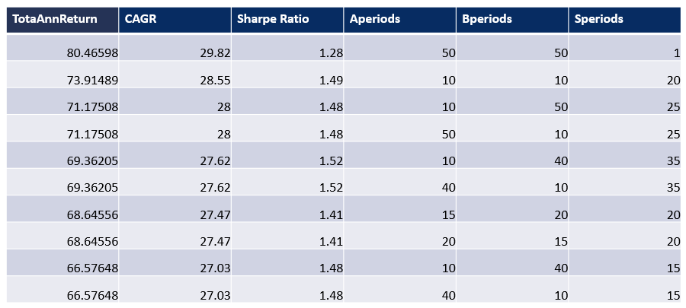

Figure 15 - Random Forest Top 10 Training Parameters Total Annual Return

The top training parameter combinations in terms of Sharpe Ratio can be seen in below.

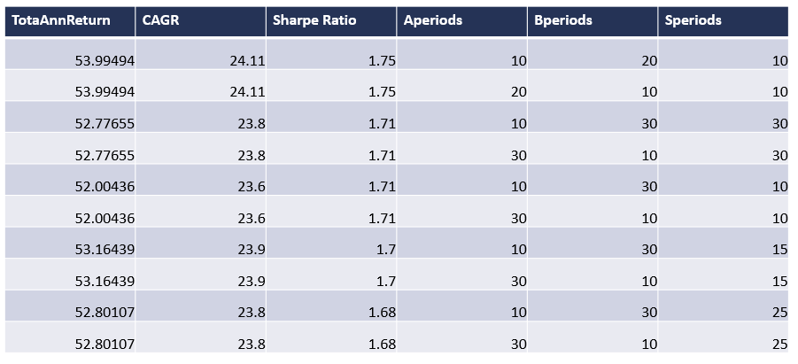

Figure 16 - Random Forest Regression Top 10 Training Parameters Sharpe Ratio

Using the top training parameter combination with respect to Total Annual Return the performance of the trading system can be seen in Figure 17 below.

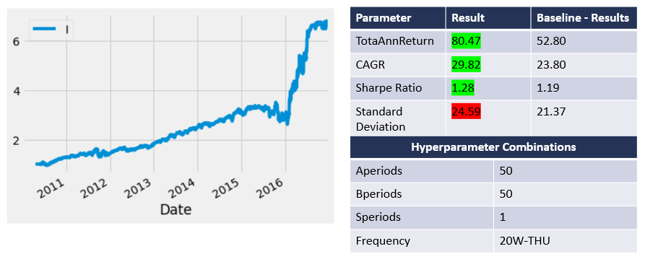

Figure 17 - Random Forest Regression Top Performing Parameter Combination on Training Set

As can be seen in the figure above the best performing training set parameter combination achieves a Total Annual Return of 80.47% with a Sharpe Ratio of 1.28. This is accomplished through a parameter combination of Aperiods = 50, Bperiods = 50, and Speriods = 1. The high return is to be expected as this is training data, and as such the predictive component will be highly accurate, thus returns for the trading algorithm should in turn be affected positively as well.

After running the top 50 performing parameters on the test set, the top 10 performing combinations with respect to Total Annual Return were found to be the following:

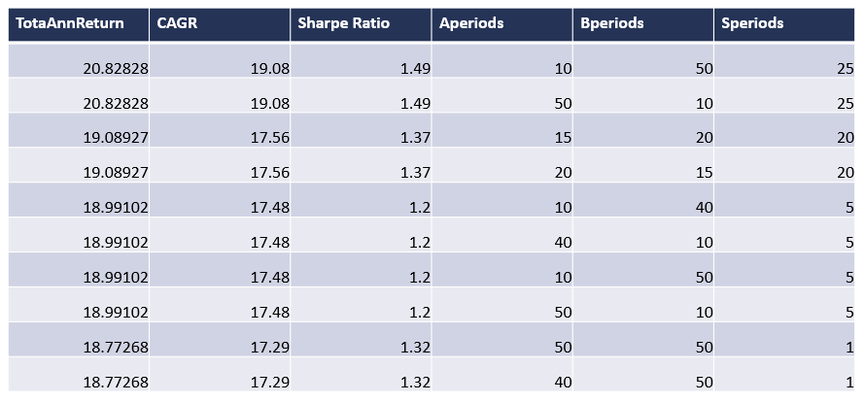

Figure 18 - Random Forest Top 10 Testing Parameters Total Annual Return

Comparing the best performing Testing data combinations with the Training data combinations, the performance of the best parameter combination across both sets on the testing data was as follows:

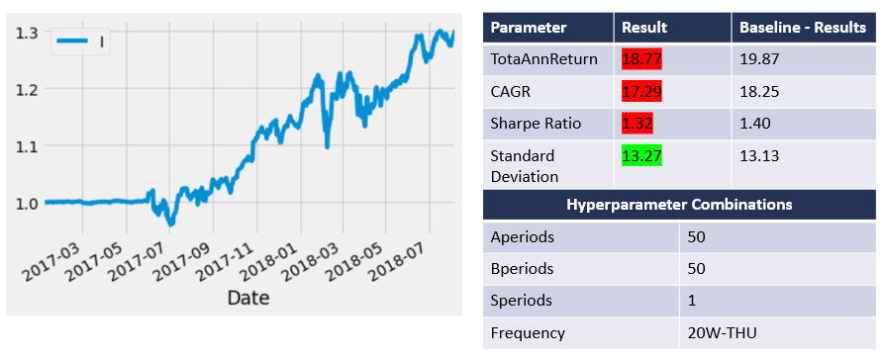

Figure 19 - Random Forest Regression Top Performing Parameter Combination on Testing Set

As can be seen in Figure 19 above the performance on the test set is worse than the baseline results with a Total Annual Return of 18.77% compared with a Baseline result of 19.87% and a Sharpe Ratio of 1.32 compared to a Baseline result of 1.40. This suggests that the inclusion of 20W predictions using Random Forest Regression is not a beneficial modification to the program. Given that the performance is close, one could argue that further tuning of the Random Forest Regression Model may yield more positive returns on the trading system, such that its performance exceeds the Baseline results. But in absence of such additional training, it will be concluded that Random Forest Regression inclusion is a non-beneficial modification to the trading system.

The full equity curve and results for training and testing data using the best parameter combination across both datasets can be found in Figure 20 below:

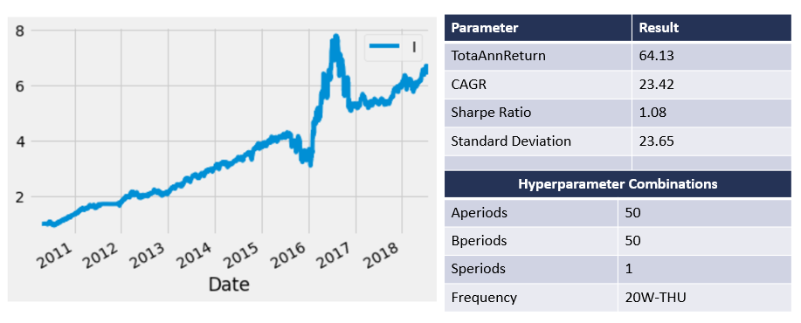

Figure 20 - Random Forest Regression Top Performing Parameter Combination on Full Dataset

**Sector Rotational Momentum with Support Vector Regression Predictions:**

The second trading system to compare against the Baseline Model is a Sector Based Rotational Momentum Program that incorporates 20W predicted returns for each ETF using Support Vector Regressions.

The top training parameter combinations in terms of Total Annual Return can be seen in Figure 21 below.

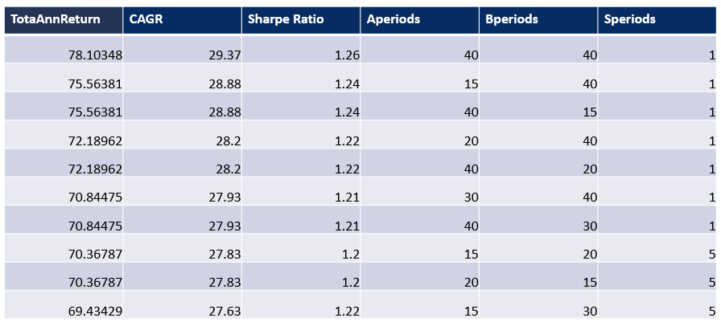

Figure 21 - SVM Top 10 Training Parameters Total Annual Return

The top training parameter combinations in terms of Sharpe Ratio can be seen in Figure 22 below.

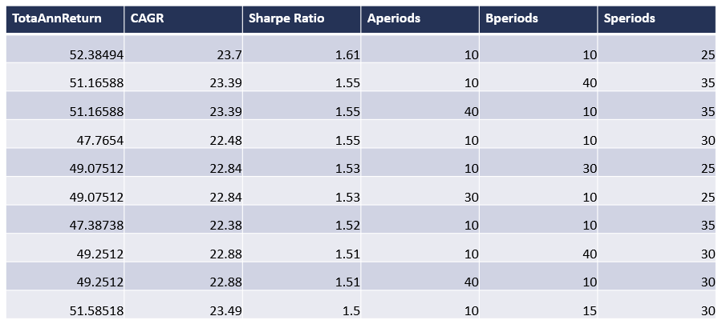

Figure 22 – SVM Regression Top 10 Training Parameters Sharpe Ratio

Using the top training parameter combination with respect to Total Annual Return the performance of the trading system can be seen in Figure 23 below.

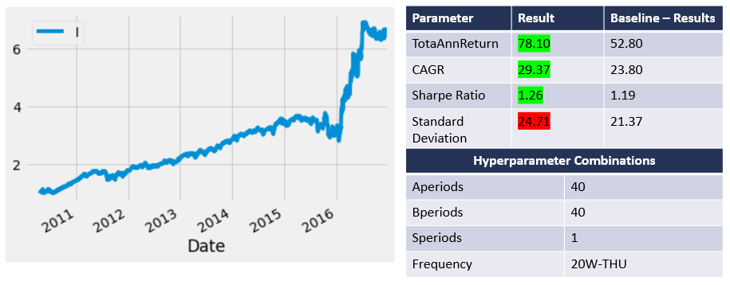

Figure 23 – SVM Regression Top Performing Parameter Combination on Training Set

As can be seen in the figure above the best performing training set parameter combination achieves a Total Annual Return of 78.10% with a Sharpe Ratio of 1.26. This is accomplished through a parameter combination of Aperiods = 40, Bperiods = 40, and Speriods = 1.

After running the top 50 performing parameters on the test set, the top 10 performing combinations with respect to Total Annual Return were found to be the following:

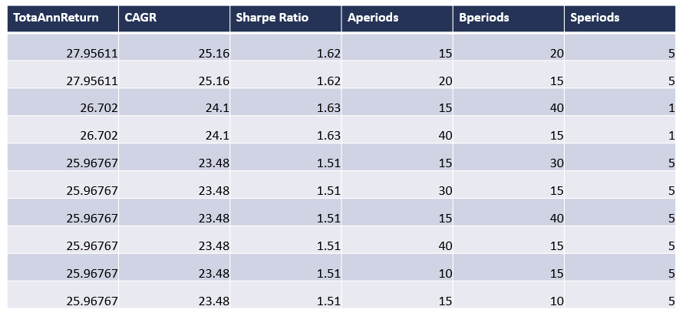

Figure 24 – SVM Regression Top 10 Testing Parameters Total Annual Return

Comparing the best performing Testing data combinations with the Training data combinations, the performance of the best parameter combination across both sets on the testing data was as follows:

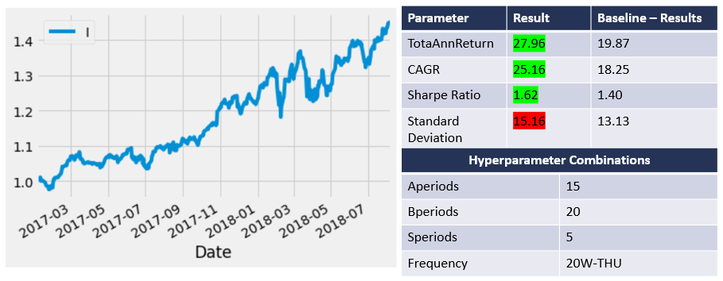

Figure 25 – SVM Regression Top Performing Parameter Combination on Testing Set

As can be seen in the figure above the performance on the test set is significantly better than the baseline model (~8% increase in Total Annual Return, and 0.22 increase in Sharpe Ratio). This suggests that the inclusion of 20W predictions using Support Vector Regression provides a significant improvement to the Rotational Momentum program.

The full equity curve and results for training and testing data using the best parameter combination across both datasets can be found in the figure below:

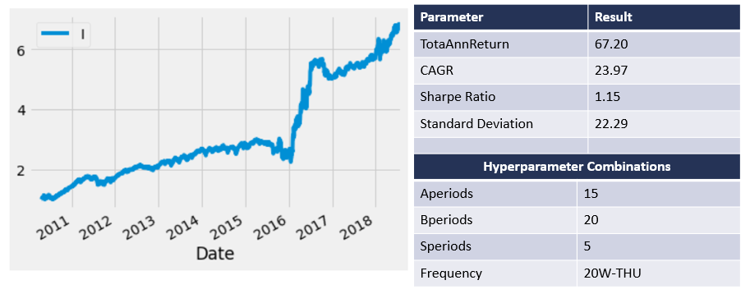

Figure 26 - SVM Regression Top Performing Parameter Combination on Full Dataset

**Sector Rotational Momentum with Random Forest Classification Predictions:**

The third and final trading system to compare against the Baseline Model is a Sector Based Rotational Momentum Program that incorporates 20W predicted returns for each ETF using Random Forest Classification. It was suspected that prior to inclusion into the trading algorithm these predictions would perform worse, as the benefit of the regression models is not per say the exact value of prediction but rather the correlation with the ETF’s actual value. Since classification reduces the information available from a correlation standpoint by truncating the possible results to 0, 1, or 2 (in this implementation at least), it would be expected that the results of this algorithm were worse than the Regression result above.

With this said the top training parameter combinations in terms of Total Annual Return can be seen in Figure 27 below.

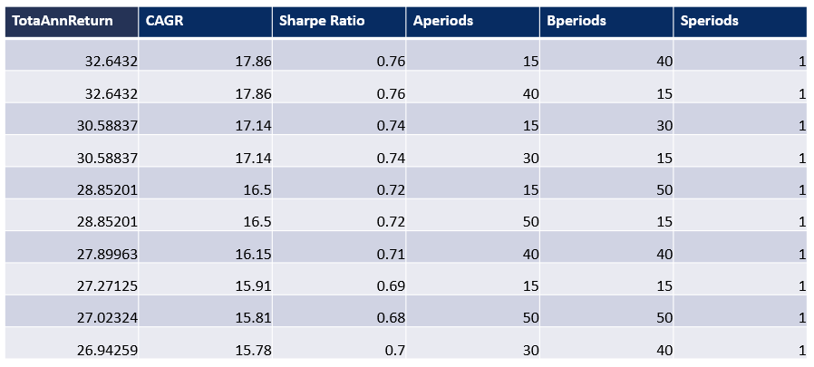

Figure 27 – Random Forest Classification Top 10 Training Parameters Total Annual Return

The top training parameter combinations in terms of Sharpe Ratio can be seen in below.

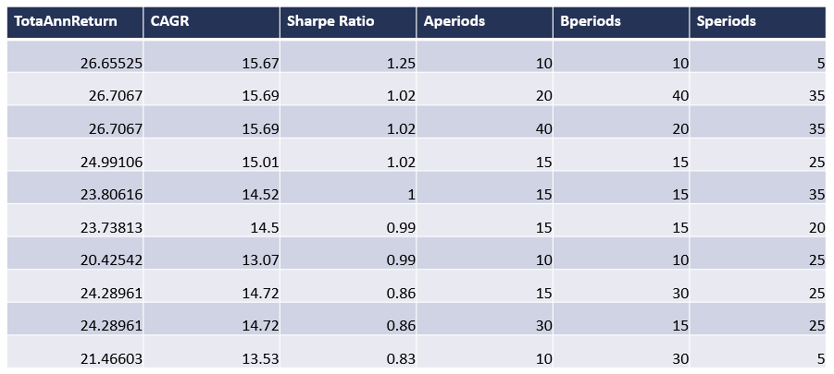

Figure 28 – Random Forest Classification Top 10 Training Parameters Sharpe Ratio

Using the top training parameter combination with respect to Total Annual Return the performance of the trading system can be seen in Figure 29 below.

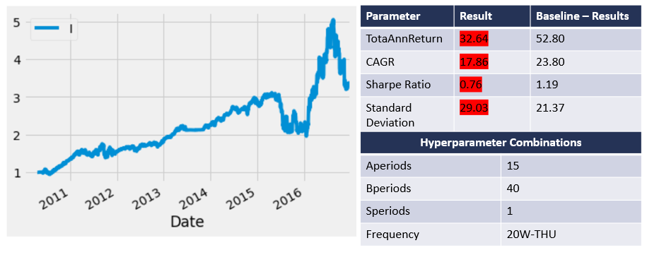

Figure 29 – Random Forest Classification Top Performing Parameter Combination on Training Set

As can be seen in the figure above the best performing training set parameter combination achieves a Total Annual Return of 32.64% with a Sharpe Ratio of 0.76. This is accomplished through a parameter combination of Aperiods = 15, Bperiods = 40, and Speriods = 1. It should be noted that these results are significantly worse than the baseline model results. Given that this is training data alone right now, it is of particular concern in terms of efficacy for the use of Random Forest Classification inclusion in the trading system as a predictor for 20W returns.

After running the top 50 performing parameters on the test set, the top 10 performing combinations with respect to Total Annual Return were found to be the following:

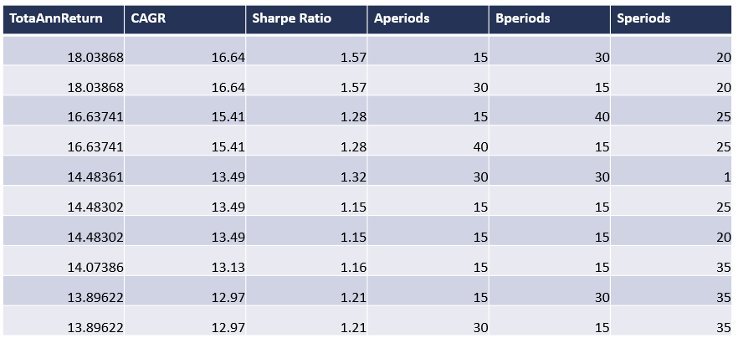

Figure 30 – Random Forest Classification Top 10 Testing Parameters Total Annual Return

Comparing the best performing Testing data combinations with the Training data combinations, the performance of the best parameter combination across both sets on the testing data was as follows:

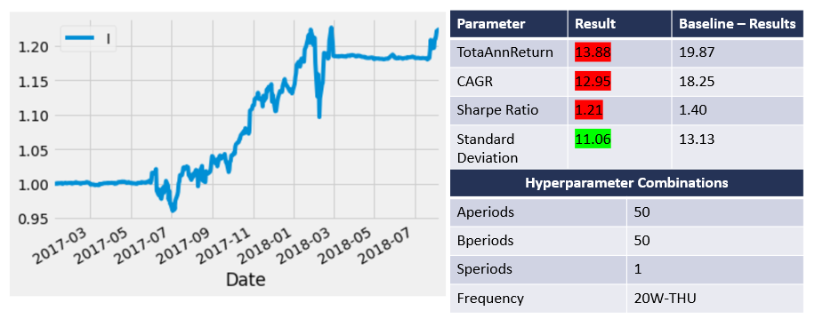

Figure 31 – Random Forest Classification Top Performing Parameter Combination on Testing Set

As can be seen in the figure above the performance on the test set is significantly worse than the baseline model (~6% decrease in Total Annual Return, and 0.19 decrease in Sharpe Ratio). This suggests as suspected that the inclusion of 20W predictions using Random Forest Classification is not a beneficial modification to the Sector Based Rotational Momentum program. It also suggests that predictors be restricted to regressors as supposed to classifiers, due to the loss of information relative to correlation that occurs with classification algorithms.

The full equity curve and results for training and testing data using the best parameter combination across both datasets can be found in the figure below:

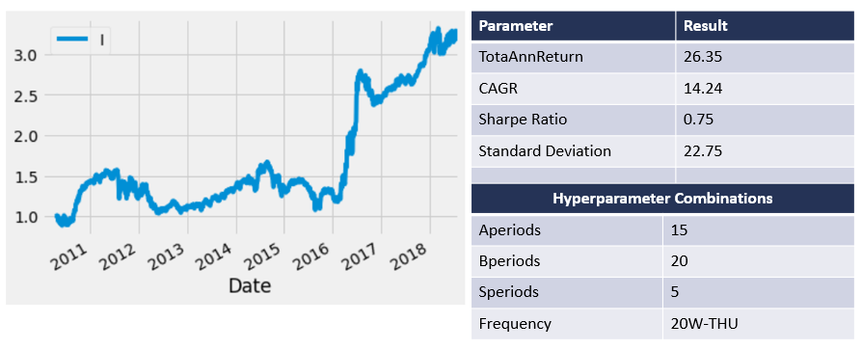

Figure 32 – Random Forest Classification Top Performing Parameter Combination on Full Dataset

**Conclusions**

The results from the three trading systems on the testing data can be found in Figure 33 below.

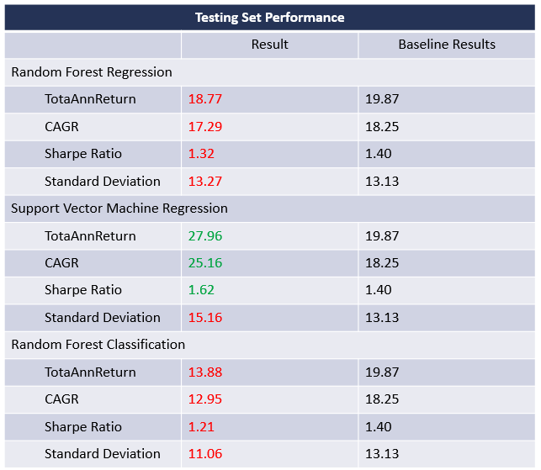

Figure 33 - Final Testing Results from Three Trading Systems

As can be seen the trading algorithms which incorporate Random Forest Regression and Random Forest Classification predictions for 20W returns perform worse than the baseline model which includes only evaluation on Aperiods, Bperiods, and Speriods. The trading algorithm which incorporates Support Vector Machine Regression on the other hand performs significantly better on the testing (and training) dataset than the baseline model. There is an 8.09% increase in Total Annual Return, a 6.91% increase in CAGR, along with a 0.22 increase in Sharpe Ratio. Standard deviation is also slightly increased by 2.03%.

These results are quite exciting and suggests that the incorporation of 20W returns using Support Vector Regression is hugely beneficial to the rotational momentum program and should warrant further investigation.

**Next Steps**

Some next steps include modifying the trading program to include predictions from an LSTM trained for each ETF for predicting 20W returns, along with Risk Management practices. It is expected that an LSTM would perform even better than the SVM regressor identified above.

Of interest in terms of risk management is the inclusion of a 200-day moving average pullout and a tiered ladder for split investments. It is expected that both would decrease volatility in the portfolio further while also potentially reducing returns slightly.

Overall these modifications should help to further make this trading algorithm more robust in market conditions.